- Unity Animation and UI Buttons Overview
  - Core Principles – Unity Scripting from extra Lectures 01 and 02
  - Unity Animation from Lecture 05 and Tutorial 04
  - Unity UI from Lecture 05

- Task 5.1 - Lego Brick Array with Unity UI Slider
5.1 Part 1 Video:
https://westminster.cloud.panopto.eu/Panopto/Pages/Viewer.aspx?id=2fddb702-a85f-4673-801c-b0a700e930e2
5.1 Part 2 Video:
https://westminster.cloud.panopto.eu/Panopto/Pages/Viewer.aspx?id=88798935-5f6d-4381-8eee-b0a700eeed66
  - Download Fbx Export Lego Brick Array Exploded
  - Drag into Unity
  - Create new Animator Controller and drag into Objects AC box
  - Add/Edit Animations in Inspector
    - Rest – Start:0, End:1, Loop
    - Explode – Start:0, End:20, Not Looped
    - Implode – Start:20, End:40, Not Looped
    - Rest Explode – Start:20, End:21, Looped
  - Drag into scene Hierarchy and zero out
  - Drag animations into Animator window
  - Default state is Rest
  - Drag transitions to the other states
  - Adjust camera to frame – adjust one axis at a time and use View Gimbal top right to navigate
  - Create UI Slider:
    - Right click in hierarchy and select UI/Slider. This creates a canvas to place it on.
    - Position by dragging values in Rect Transform on Canvas/Slider:
Slider Exploder (200,-200,0)
  - Add New script ExploderSlider.cs to Brick Array Game Object and type in as below:

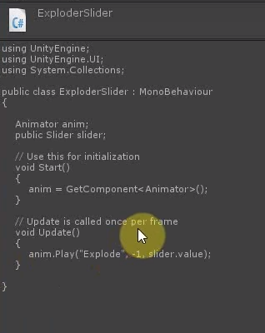
  - Drag Slider Game Object into the box exposed in Inspector by this script
  - Test

  - Start with last scene
  - Add new UI Slider on Same Canvas
    - Name as rotator
    - Position as needed by dragging values in Rect Transform on Canvas/Slider: Slider Rotator (-200,-200,0)
    - try Rect Transform box presets with Shift and Alt to position Automatically
  - Slider script:
    - In Max Value – type in 360
https://gyazo.com/ad79db9c27aa9ef697f173bb60b560aa
  - Add New script RotatorSlider.cs to Brick Array Game Object and type in as below:
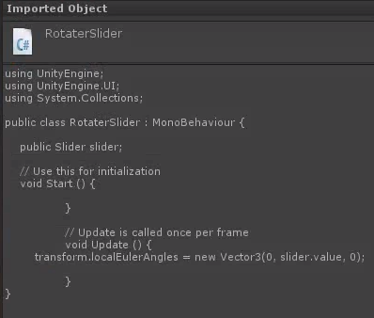
  - Drag Slider Game Object into the box exposed in Inspector by this script
  - Test
  - Try the extra script included below for extra interactivity

- Task 5.2 - Lego Widget Minifig Animation with Unity UI Buttons
5.2 Video: https://westminster.cloud.panopto.eu/Panopto/Pages/Viewer.aspx?id=ec71b024-f952-4e2c-9c03-b0a700f65952
  - Use Lego character built from Mecabricks animated in Max
    - Widget02StandWalk
    - Stand, walk, and flip animations
  - Import to Unity, make Animator Controller
  - Edit Animation timeline in Inspector to create stand, walk, flip
    - Stand – 0,0 - looping
    - Flip – 0,20 - looping
    - Walk – 20, 60 - looping
  - Put animations in Animator window with Stand as Layer Default State, and Flip and Walk with transitions from Entry State
  - Create Unity UI Button
    - Screen space overlay
    - In button anchors box, click to enter
    - Hold down alt and select centre or top to snap button position
    - Drag button to desired position with rect transform
  - Add an on-click event for button
    - Drag Lego minifig into exposed box
    - Select Animator play string name option
    - Type in name of animation from animator
  - Test
    - Try turning loops on and off
    - Try combinations of buttons and scripting by using below script on the Lego Figure
- Task 5.3 - Try the same with the Lego Minifig fbx in Blackboard for CW1

Code:
Task 5.1 - Lego Brick Array Extra script to try – Mouse input (may conflict with other scripts – try it!)
Exploder.cs
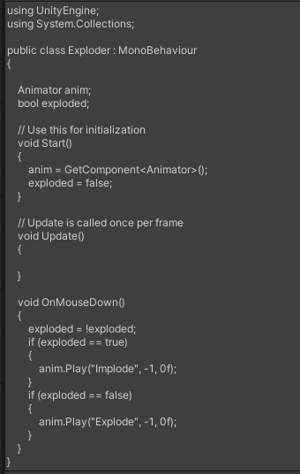
Task 5.2 – Scripted Animation Control
AnimPlay.cs
}

